**Buy Verified PayPal Account**

Buy Verified PayPal Account from usabuysmm Assistance Are you looking for a seamless way to manage international transactions? Our team provides secure solutions to help you verify your PayPal account and ensure hassle-free payment acceptance across the globe.

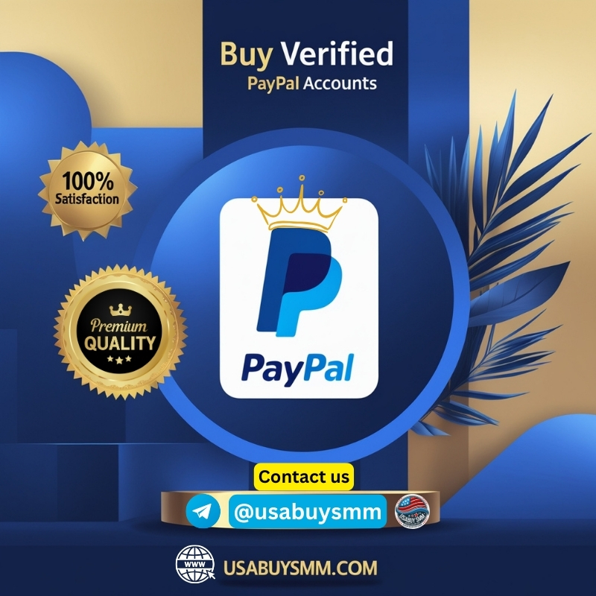

**Why Choose Our Service?**

* Access multiple currency options for your business.
* Expand globally with verified account support.
* Enjoy 24/7 customer assistance for all your needs.

**What We Offer:**

* Verified PayPal account setup.
* Documentation support (ID, driving license).
* Bank account and email login assistance.
* Reliable and professional service at competitive rates.
* Benefits of Verified PayPal Accounts:
* Build trust with international customers.
* Simplify your online payment process.
* Enhance your e-commerce experience

**If you encounter any issues, please feel free to contact us.**  
**We are available online 24/7.**  
**Telegram:**[**usabuysmm**](https://t.me/usabuysmm)  
**WhatsApp:**[**+1(929)2439320**](https://wa.me/19292439320)  
**Discord: @usabuysmm**  
**Email: usabuysmm@gmail.com**  
**Outlook: usabuysmm@outlook.com**  
**Private chat**  
**Protonmail: usabuysmm@protonmail.com**

**Top Reasons to Buy Verified PayPal Account: Secure, Fast, and 100% Reliable (Guide)**

**Introduction to Buy Verified PayPal Account**

Buy Verified PayPal Account In the world of online payments, a “verified” PayPal account is one that has been fully authenticated by linking and confirming a bank account or credit card. This process confirms the identity of the user, enhancing credibility and reducing the risk of fraud.

When a PayPal account is verified, it lifts limitations that typically exist on new or unverified accounts—such as transaction caps or sending/receiving restrictions. For many online users, having a verified PayPal account isn’t just convenient—it’s essential for business operations.

**What Is a Buy Verified PayPal Account?**

**Definition and Importance**

A verified PayPal account is one that has undergone full identity and banking verification. This typically includes linking and confirming a bank account or credit card, verifying email and phone, and in some cases, confirming a government-issued ID. Verified accounts are viewed as trustworthy and are less likely to face limitations or restrictions.

**Differences Between Verified and Unverified Accounts from**[**Google**](https://www.google.com/)

| **Feature** | **Verified Account** | **Unverified Account** |
| --- | --- | --- |
| Withdrawal Limit | High / Unlimited | Restricted |
| Payment Send/Receive | Full Access | Limited |
| Security Checks | Reduced | Frequent |
| Trust Level | High | Low |

Unverified accounts are seen as higher-risk by PayPal, which can result in sudden holds or bans.

**Why Verification Matters**

Verification builds trust. Whether you’re a freelancer receiving payments or a seller collecting money from customers worldwide, having a verified PayPal account signals legitimacy. It also protects users from scams and unauthorized access. Unverified accounts often face restrictions or can even be suspended unexpectedly, which can disrupt your financial activities.

**Buy Verified PayPal Account**

**Types of Buy Verified PayPal Account Available Online**

**Personal vs. Business Accounts**

* **Personal:** Ideal for freelancers or individual use
* **Business:** Suitable for e-commerce, agencies, and enterprises

**USA, UK, EU, and Offshore Accounts**

Some marketplaces specialize in region-specific accounts, helping users bypass geo-restrictions.

* **USA Accounts:** Good for eBay and Amazon
* **UK Accounts:** Preferred in EU markets
* **Offshore Accounts:** Discreet but risky

**Why People Buy Verified PayPal Account**

**Common Use Cases**

* **Freelancers:** To receive payments without delays
* **E-commerce Sellers:** For international sales and credibility
* **Digital Marketers:** To run PayPal ads
* **High-risk Businesses:** To avoid compliance delays
* **Crypto Traders:** To manage transactions discreetly

**Trust and Credibility in Online Transactions**

A verified PayPal account signals authenticity to customers and clients. In industries where fraud is a concern, this credibility is crucial for maintaining smooth financial operations.

**Key Benefits of Buy Verified PayPal Account**

**Faster Transaction Limits**

A verified PayPal account removes sending and withdrawal limitations, allowing you to move larger amounts of money without delay. This is especially useful for high-volume sellers or professionals managing multiple payments daily.

**Enhanced Account Security**

Verification adds a layer of security through bank or card authentication, making it harder for hackers to compromise your account. This is a key advantage for individuals who store significant funds in their PayPal wallets.

**Access to More Features**

With verification, users gain access to a wider range of services, such as merchant tools, recurring billing, and multi-currency support—important features for businesses operating globally.

**Enhanced Transaction Limits**

Buy Verified accounts enjoy fewer transaction limits, making it easier to run a business without interruptions or freezes.

**Improved Security**

These accounts are less likely to trigger PayPal’s fraud filters, reducing the chance of sudden account holds.

**Access to Full Features**

Buying a verified account gives immediate access to:

* Instant transfers
* Currency conversions
* Business tools and invoicing
* PayPal.me links and subscriptions

**Who Needs Buy Verified PayPal Account?**

**Freelancers and Digital Nomads**

Freelancers working on platforms like Up work or Fiverr often require verified PayPal accounts to receive payments. A verified status ensures quick transfers and builds trust with clients.

[**ecommerce Sellers**](https://www.quora.com/)

Whether you’re on Shopify, eBay, or Woo Commerce, verified accounts are a must. They offer better buyer protection and allow seamless payment processing.

**Affiliate Marketers**

Marketers promoting products across borders benefit from verified PayPal accounts as they receive affiliate commissions in multiple currencies without unnecessary delays.

**Is It Legal to Buy Verified PayPal Account?**

**PayPal Terms of Service Overview**

Technically, buying or selling PayPal accounts violates PayPal’s Terms of Service. Each account is meant to be tied to a specific individual with verified identification. However, enforcement varies and many users still engage in such transactions discreetly.

PayPal’s [terms](https://www.wikipedia.org/) explicitly prohibit the sale and transfer of accounts. If discovered, the account could be limited or banned. Therefore, buying from reputable sources and using stealth methods (changing IP, email, etc.) is key to longevity.

**Legal Risks Involved**

There is a risk of permanent ban if [PayPal detects account](https://www.paypal.com/) transfer or mismatched login data. Users must weigh these risks carefully and take necessary precautions if proceeding with a purchase. The legality of buying accounts varies. In some countries, it’s allowed if done transparently. In others, using someone else’s details may violate financial laws. Always consult local regulations.

**Risks of Buy Verified PayPal Account**

**Getting Scammed**

The biggest risk is falling victim to fraudsters who disappear after payment or deliver unusable accounts. Always vet sellers thoroughly.

**Account Limitations**

Even verified accounts can face restrictions if suspicious activity is detected. If flagged, PayPal may freeze the account for 180 days or more.

**PayPal Bans and Freezing**

If PayPal finds out that an account was bought or accessed from a suspicious location, it may ban the account permanently, locking your funds inside.

**How to Identify a Legitimate Verified PayPal Seller**

**Red Flags of Scammers**

* Vague answers to questions
* No customer support or reviews
* Asking for cryptocurrency only

**Trusted Sources and Marketplaces**

Check[**usabuysmm Buy Verified Accounts – Cash App, PayPal, & More**](https://usabuysmm.com/) where user feedback and seller ratings are transparent. Dedicated account selling services with good reputations are usually safer options.

**Essential Features of a Verified PayPal Account**

**Linked Bank Account or Card**

All verified accounts must be linked to an active bank account or credit card. This is what differentiates them from unverified ones.

**Email Verification**

The registered email should be confirmed, ensuring PayPal communications go to the right person.

**Transaction History**

Some premium accounts come with existing transaction history, which adds credibility and reduces the chances of being flagged.

**Step-by-Step Guide to Buying a Verified PayPal Account**

1. **Research and Select a Seller**  
   Choose one with high reviews, clear contact options, and refund policies.
2. **Confirm Details**  
   Ask for a screenshot of the dashboard, verification proof, and creation date.
3. **Make the Payment**  
   Use secure gateways like Escrow or PayPal itself (ironically), if available.
4. **Change Login Info**  
   Update email, password, and security questions immediately after receiving the account.
5. **Enable 2FA**  
   Set up two-factor authentication for added security.

**Recommended Platforms to Buy Verified PayPal Account**

[**USABUYSMM.COM**](https://usabuysmm.com/)

**Specialized Vendors**

Some websites specifically sell verified PayPal account. Examples include **USABUYSMM.COM**  although user discretion is advised.

**Social Media Sellers like USABUYSMM**

Facebook groups and Telegram channels sometimes offer deals. These are riskier but may offer competitive prices.

**Price Comparison: How Much Does It Cost?**

| **Country Type** | **Average Cost (USD)** |
| --- | --- |
| USA | $60 – $150 |
| UK | $70 – $160 |
| EU | $50 – $140 |
| India | $40 – $100 |

**Factors Affecting Price**

* Age of account
* Verified status with bank or card
* Transaction history
* Risk of ban or dispute

**Tips to Avoid Getting Banned After Purchase**

**Changing IP and Location**

Use a clean IP address from the country of the account. VPNs or residential proxies help mimic the account’s original setup.

**Updating Information Carefully**

Don’t change all details at once. Make gradual changes over a few days to avoid suspicion.

**Alternatives to Buying a Verified PayPal Account**

**Creating One Yourself**

In some regions, getting verified is easy. All you need is a bank account, phone number, and ID.

**Using Other Payment Gateways**

Consider [**Buy Stripe Accounts**](https://usabuysmm.com/product/buy-verified-stripe-accounts/)**, [Payoneer](https://usabuysmm.com/product-category/banking/" \t "_blank), Skrill, or Wise as**[**alternatives**](https://usabuysmm.com/product-category/banking/)**.** They offer similar features and are often easier to set up.

**Testimonials: What Real Users Say**

“I bought a verified US PayPal account for $90, and it’s been working perfectly for 6 months now.” — *J. Patel, India*

“Got scammed once on Telegram, but had better luck using Escrow on EpicNPC.” — *Laura M., Philippines*

**FAQs About Buy Verified PayPal Account**

1. **Is buying a verified PayPal account safe?**  
   It’s risky but can be safe if purchased from a trusted seller and used cautiously.
2. **Can PayPal detect if I bought an account?**  
   Yes, especially if you log in from a suspicious IP or change info too quickly.
3. **Will I get my money back if the account is banned?**  
   Not always. That depends on the seller’s refund policy.
4. **Can I change the email and password?**  
   Yes, and you should do this immediately after purchase.
5. **Are there country restrictions?**  
   Yes. Some accounts are region-locked or work best within their original country.
6. **What is the best payment method for buying one?**  
   Escrow or PayPal (with buyer protection) is safest. Crypto is riskier.

**Conclusion: Is Buy Verified PayPal Account Worth It?**

**Final Thoughts**

**Buy verified PayPal account** can be a game-changer for those struggling with verification due to location or documentation issues. However, it’s crucial to weigh the benefits against the risks.

**Best Practices for**

* Choose reputable sellers
* Use secure payment options
* Change information slowly and securely
* Always have a backup payment platform

For those who can’t access PayPal easily, purchasing a verified account may be the bridge to global commerce. But it must be done wisely and responsibly. When discussing the acquisition of verified PayPal accounts, it is essential to exercise caution and adhere to ethical practices. There are valid reasons for wanting a verified PayPal account, such as facilitating business growth or accessing special features. However, it is crucial to ensure that the methods employed comply with PayPal’s terms and conditions. We have numerous customer reviews available for you to explore. If you are in search of a verified PayPal account, we are your best partner, offering accounts at an affordable price. You can trust our account services without hesitation.

**We are available online 24/7.**  
**Telegram:**[**usabuysmm**](https://t.me/usabuysmm)  
**WhatsApp:**[**+1(929)2439320**](https://wa.me/19292439320)  
**Discord: @usabuysmm**  
**Email: usabuysmm@gmail.com**